Dear future presenter,

When you’re designing your slideshow, think about how your classmates will view every slide. Don’t be afraid to have some slides with minimal information. Perhaps Ms. Smith-Ferris stay with you, but in my opinion slides filled with text are the quickest way to lose the rest of your audience. Instead, put a small amount of information on your slides and use your speech to expand on those ideas.

As an example of a minimal-information slide, consider this:

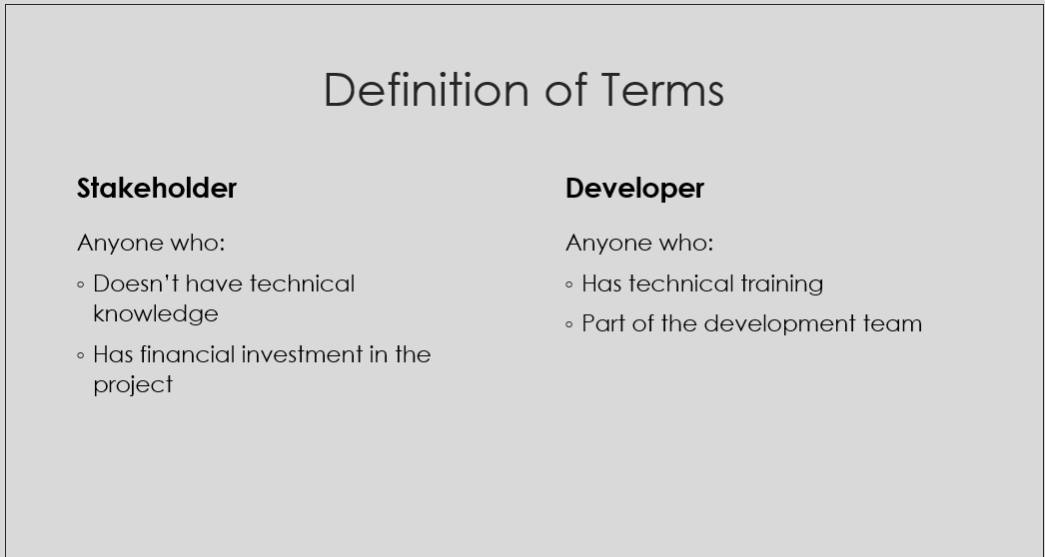

This slide could certainly be improved aesthetically, but it succeeds on emphasizing the importance of the two terms. I think there’s an inverse relation between how much text is on the slide and how important the audience perceives the text’s content to be. With low information they will perceive high importance; with a burden of information they will perceive low importance. Since the rest of my presentation doesn’t make sense without an understanding of these terms, I decided to give them their own slide so they couldn’t possibly be overlooked.

Another way to engage your audience is to use humor. Instead of attempting to explain am advanced topic like asymptotic analysis, I instead used this comic:

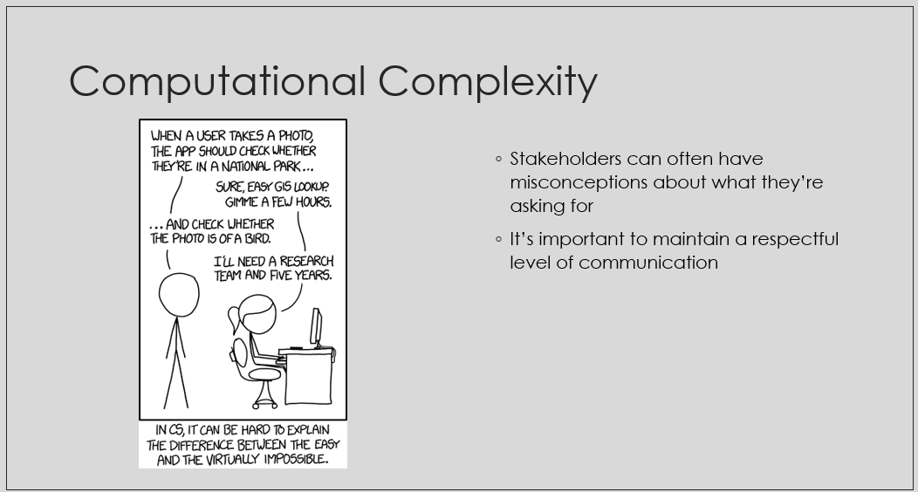

This comic serves two purposes. The first is to grab the audience’s attention with a (relatively) interesting image. The second is that it adequately provides a loose summary of the topic at hand.

Your classmates have different majors and backgrounds, so they are likely not knowledgeable of your topic. They will be looking for things to relate to, and using humor or a relevant comic can give them something to latch on to. Additionally, it can regain their attention if they’ve lost interest. Most students won’t make their presentations this accessible, so it can help yours stand out. Of course, there’s a line between accessible and unprofessional, but I’ll leave that to your judgment.

When you’re what you’ll say during the presentation, you have a few options: entirely scripted, partially scripted, or unscripted. While I don’t think it’s necessary to script every single word, having a thorough plan is the best way to make sure you stay on track and don’t lose your train of thought. I find that when I do the “real” presentation/take tangentially related topics jump into my mind, and I’m tempted to talk about them. You can see this from 6:22 to 6:31 in my presentation, when I improvise relating the topic to a student’s experience.

While this is a relevant aside, I misspoke the line and broke the logical progression of this slide. Looking back, I should’ve started started with the story about students struggling on a project while rewording “hours later” to “at 1am” (“only take a couple hours, then hours later” is quite awkward). After this anecdote, I could expand the idea by saying poor time estimation is unavoidable in the industry before concluding that the developers should make stakeholders aware of this phenomenon. I find that I tend to derail myself when I improvise, but it’s certainly possible to improvise a presentation and still sound intelligent. The best advice I can give is to be aware of your own strengths and weaknesses when speaking and tailor your presentation style accordingly.

Possibly the best way to set your presentation apart is through your tone of voice. A common theme throughout your classmates’ presentations will be that most students will speak in a dry, monotone manner.

To be honest, this is one of the areas where I’m least competent. I personally find that when I attempt to show emotion, the “voice in my head” sounds nuanced and utilizes inflection. However, when I play back the recording I sound completely monotone. Although it might be uncomfortable, I recommend listening to snippets of your own presentation and noting places you can improve.

I find that emphasizing callbacks to ideas/keywords discussed earlier in the presentation to be essential. While you know the narrative you’ve constructed throughout the presentation, it’s easy to forget that the audience does not. By clearly exaggerating callbacks to ideas or keywords you’ve previously discussed, the audience will be more likely to pick up on the connection. When the audience follows the presenter’s train of thought, the presenter can lead the audience to simultaneously reach the same conclusion.

If you’re able to use this process to eventually deliver a clear presentation that projects enthusiasm, you’ll be far better off than the rest of the class.

Another piece of advice I haven’t really seen before is to emphasize practicing the end of your presentation. When I was recording, I would begin the presentation but mess up and end early more often than not. By the time my recordings were usable, I had far more practice with the first half of my presentation than the second half. The result was far less competency in delivering my conclusion than I would’ve liked. From 7:22 to 8:20 is especially bad. The entire presentation has been leading to this idea, but I misspeak several times while stumbling my way through this slide. I also didn’t have a script for this section because I thought the concept was simple enough that I could convey it clearly, but that obviously wasn’t the case. The conclusion is one of the most important pieces of a presentation, and I think it would’ve benefited from more focused practice.

While I stand by all of the recommendations above, the most important piece of advice I can give is to remember that your presentation will never be perfect. Create a plan, refine that plan, and practice, but eventually just deliver the final product. Finding flaws in your work can help strengthen it, but it has it’s limits. I spent too much time over-criticizing myself and it dismantled my progress. One aspect of perfectionism is feeling that if something can’t be done perfectly, you might as well not even try.

Best of luck, and it’s only as big of a deal as you make it out to be.

Adam Karl

